Palindrome Program

Description:

The palindrome checker takes an input (a potential palindrome) and initially checks if there is a space in the word. If so, the program will return with an error saying that the user has entered a sentence and not a word. If the word passes this check, the program will continue. The program then reverses one letter at a time and stores this new reversed word into a variable. If the reversed word matches the initial word then, then the program will return with a message saying that the word the user had typed was a palindrome. If they don’t match, the program will return with a message saying that the word the user had typed in is not a palindrome.

Code:

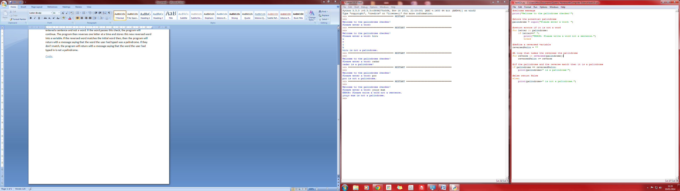

Outputs:

(Correct palindrome):

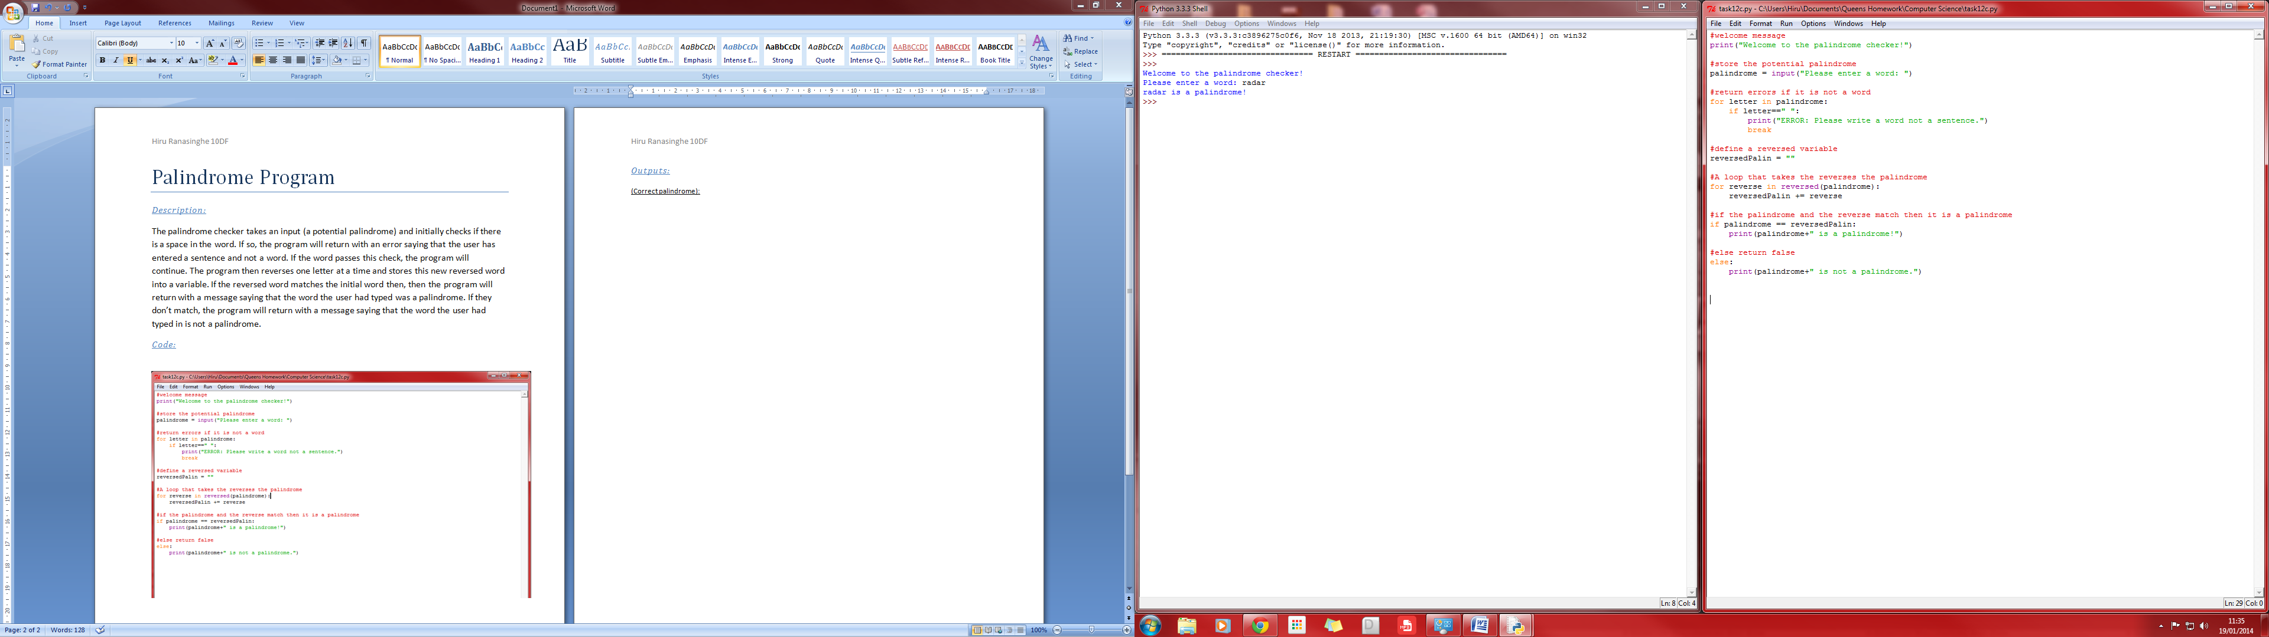

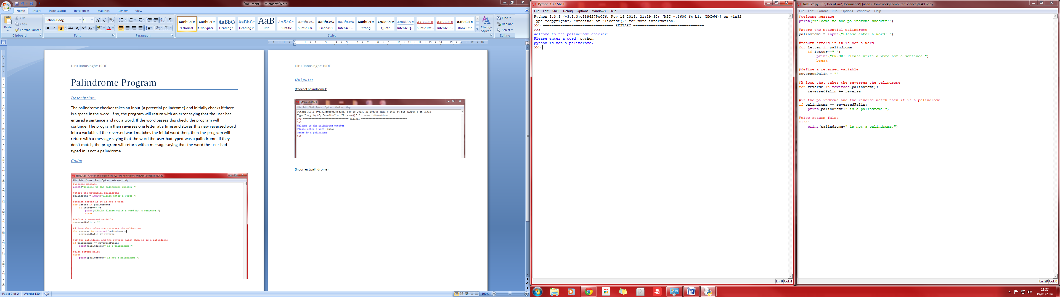(Incorrect palindrome):

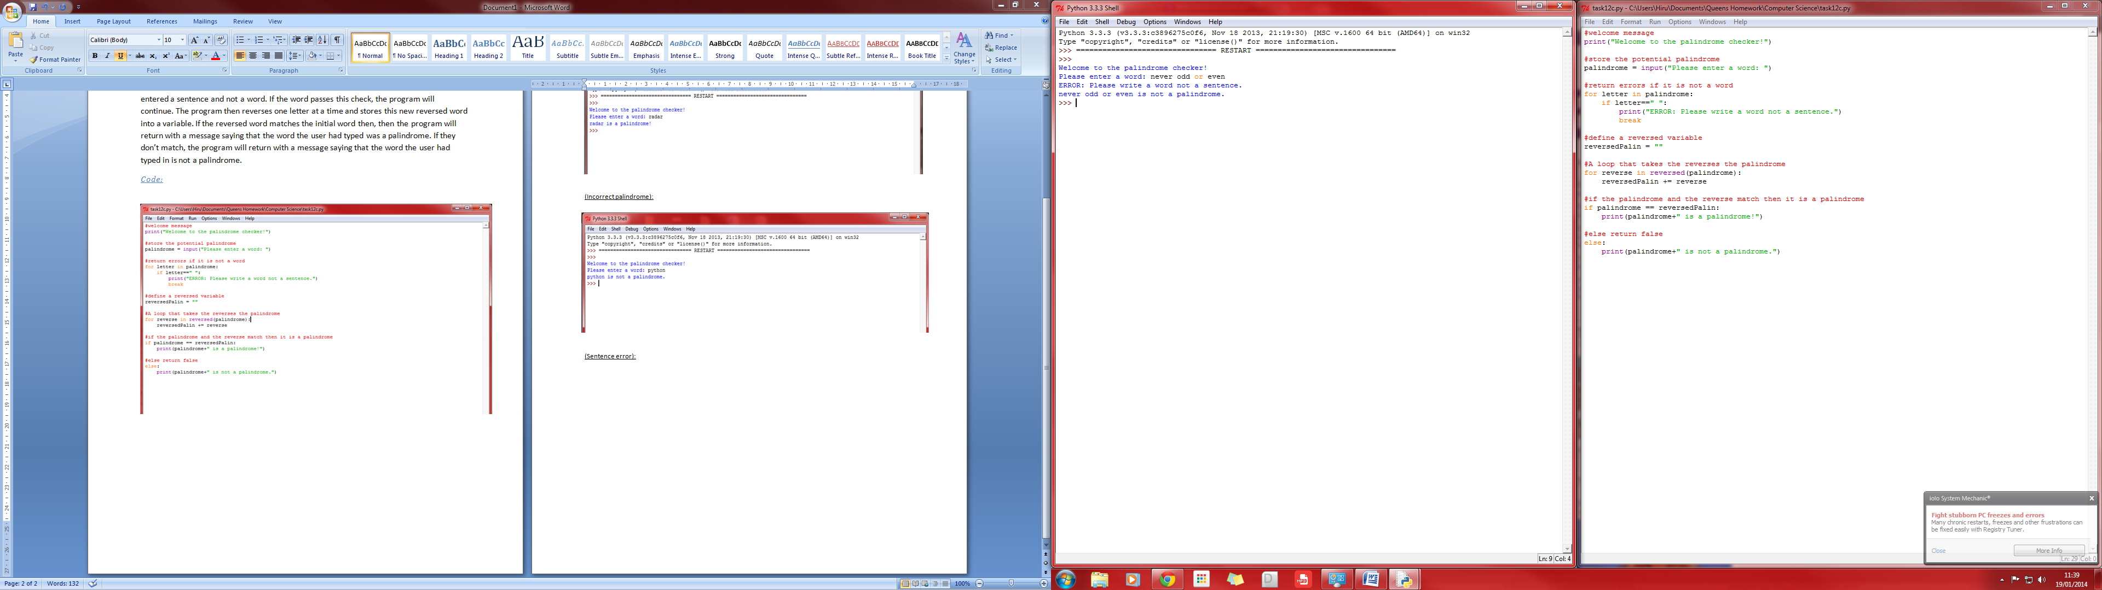(Sentence error):